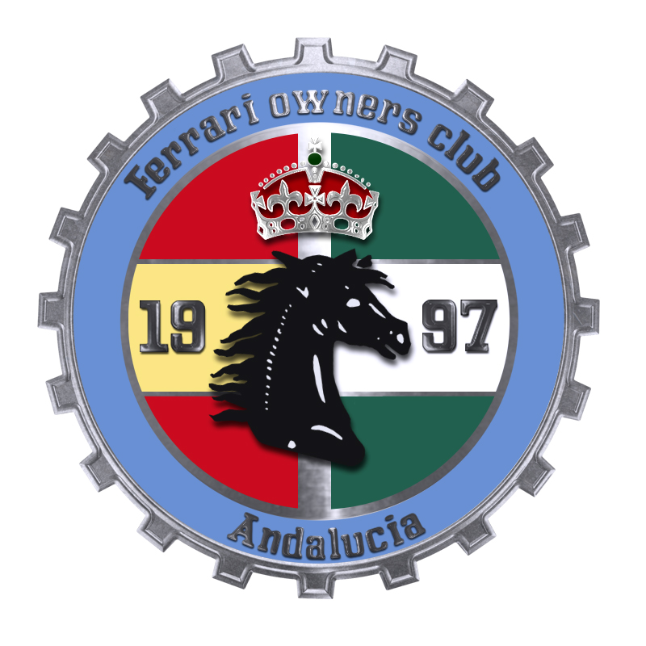
A scenic tour through the Southern Andalucian mountains with Porsche and Ferrari clubs

Dear Members,

The two clubs are arranging a scenic tour in the southern Andalucian mountains. It is one of the most beautiful routes around, especially now when spring is opening its doors. We start from La Cañada shopping center in direction to El Burgo where we will have a quick pits stop before heading in direction to Ronda. Outside Ronda we will stop again and the Porsche Club will offer refreshments. We end the tour in the newly opened restaurant El Perejil on the N340 just before Estepona. The tour takes in all 4 hours and we drive about 140 kilometers.

If you have not been driving this route before, do not miss this opportunity, it is a very spectacular trip. The drivers will be challenged with the curvy mountain roads. All the way we are offered wonderful views over the Andalucian landscape. In the last stretch you will have views over the whole coastline from Marbella to Gilbraltar before enjoying a typical Spanish lunch.

The registration is 10 euro/car for the rally and 35 euro/person for the lunch.

For those that just want to come for lunch, make the same application and specify just lunch and pay at restaurant. In case of no show payment is still necessary.

Application at latest the 15 th of March and with name of participants. (with choice of main course for each participant) by email to peter.gavrell@telefonica.net

If you later cannot attend send an email to peter.gavrell@telefonica.net or call Victoria 644416501

Attached
- Menu with choice of main course -> send choice to us
- Roadbook
- Programme

Welcome
Peter and Sally. Charlie and Victoria.
POCA. FOCA

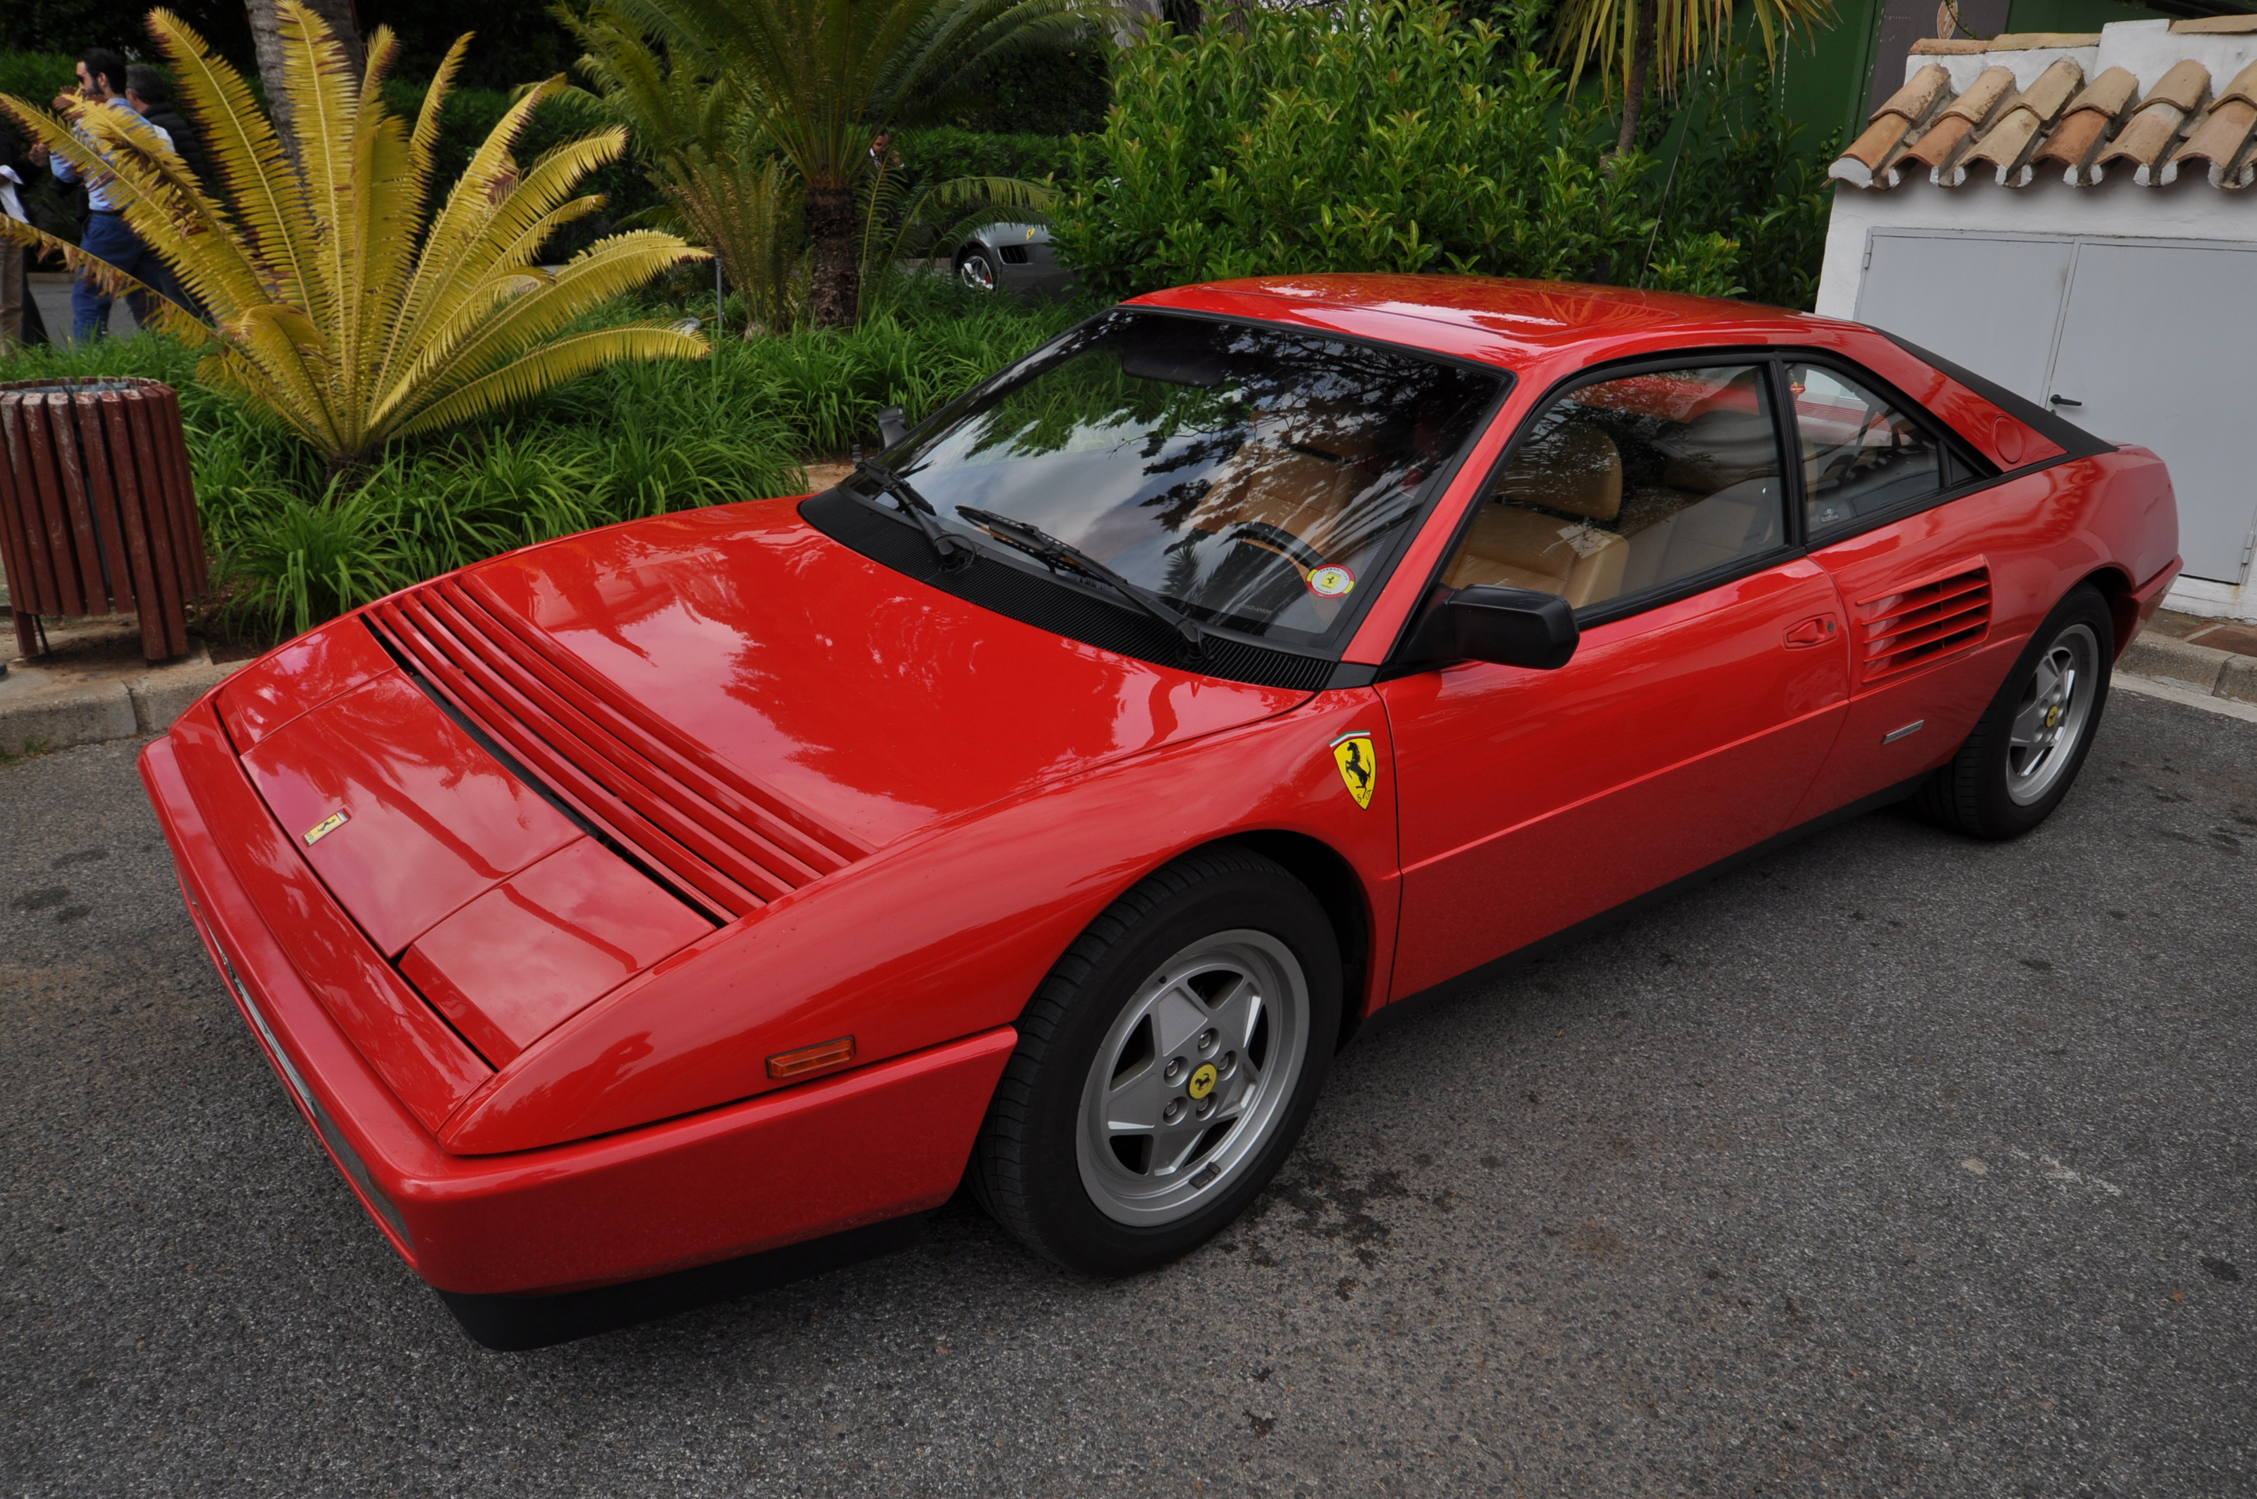
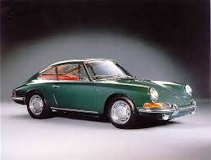

Programme

(9.00 cafe Monuca, close to the main entrance of La Canada, opens for those who want to eat breakfast)

Arrival to café at latest:
10.00 Registration and payment (10 euro + 35 euro/participant)

10.20 Presentation of the Clubs Peter/Charlie

Car quiz during transport

10.30 We leave La Canada

About 11.30 We arrive at El Burgo for a break (you pay for your consumption) to stretch our legs and have some refreshmants

At 12.15 We leave in direction Ronda

About 13.00 we stop outside Ronda for a break, Porsche Club offers refreshments, and to stretch our legs

At 13.46 We leave in direction San Pedro

About 14.30 we arrive at restaurante El Perejil for lunch.

Roadbook

It is important that you set your trip meter to 0

Time | Km | Place
0 | 0 | Canada Marbella
 | 16,5 | Exit Monda
17 m | 25.4 | In Monda take to the left in the T-crossing
 | 38.1 | Drive trough Gauro and in the roundabout take to the left
29 m | 25.4 | In the T-crossing take to the left
41 m | 38.1 | Close to Alozaina in the roundabout take to the left direction Burgos
52 m | 46.8 | Yunquera direction Burgos
1 h | 55.6 | Take to the left after the bridge.Burgos. Stop at Café Casa Pepe  Park anywhere you can.
1.45 | 55.6 | We leave Burgos in direction Ronda
2.15 | 80.9 | You are in Ronda.In the roundabout take to the left direction San Pedro
 | 88.4 | Speedcamera 80 km/h
2.30 | 98.3 | Parking place. Stop. Brake for refreshment
3.15 | 98.3 | We leave direction San Pedro
 | 109.8 | Speedcamera 60 km/h
 | 111.9 | Speedcamera 60 km/h
 | 127.4 | Roundabout (polica station) before exit to motorway, take right in direction Los Arqueros and Benahavis
 | 130.9 | Cross the Benahavis road straight ahead uphill
 | 135.4 | T-crossing to the left uphill
 | 139.3 | Cancelada in the roundabout take to the right and then to the left go straight ahead
 | 139.7 | Take to the left on the Carretera de Cadiz direction Estepona
4 h | 142.1 | Exit Selwo/Aventura. You have reached restaurant El Perejil

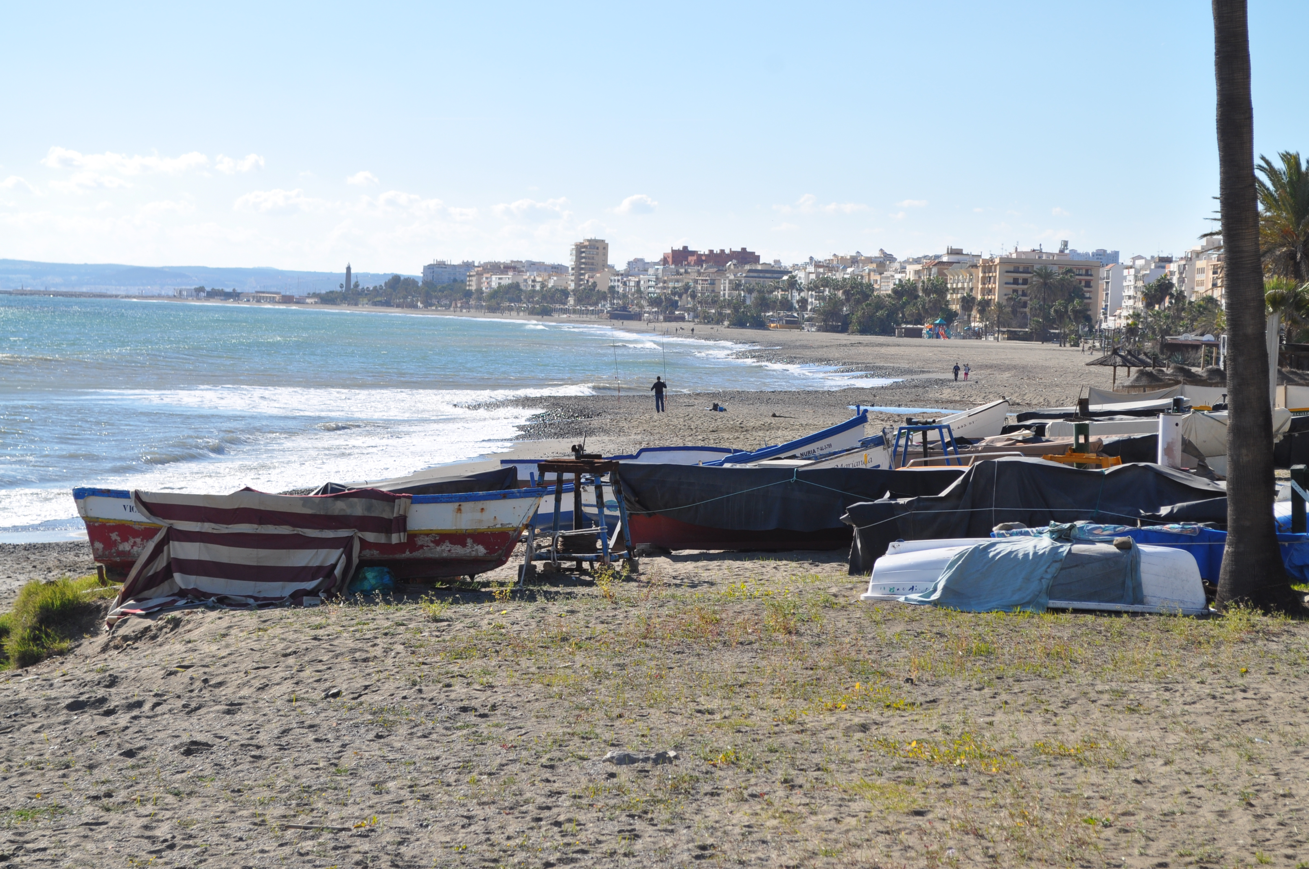

Menu

Starters

Salmorejo con huevo y jamón

Ensalada de aguacates con gambas

Main course

- Solomillo de cerdo a la brasa

Or

- Salmon a la plancha con salsa verde

Choice must be communicated in advance when you do the application

Dessert

Postre casero
Coffee

Half a bottle wine or beer or soft drinks
Water

Price 35 euro incl tips

