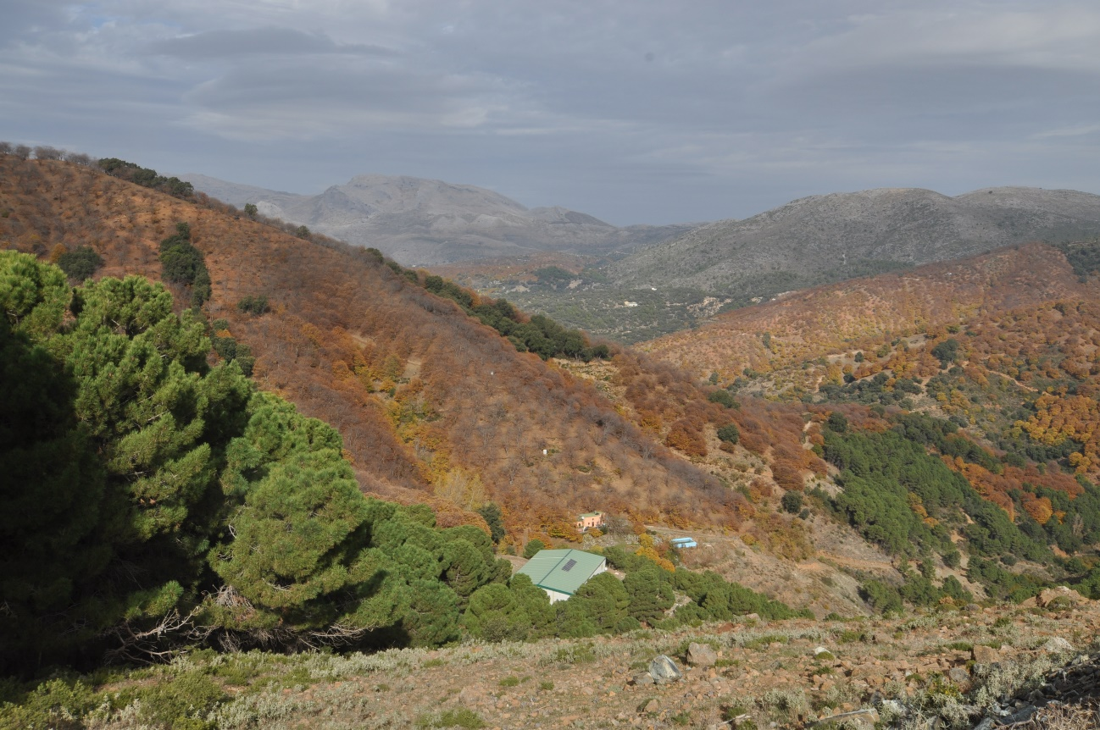

POCA Countryside Rally March 23rd
Welcome to our countryside rally.

We start in Sotogrande at restaurant KE at 10.00. Those who want to eat breakfast need to come much earlier.
We have to leave 10.30 al punto
The rally goes through the countryside landscape with green fields and spring flowers. Horses and bulls on the fields. You meet the spring with the trees just starting to show its leaves.
Halfway we will take a coffee brake in Gaucin and have the views of the mountains as a background. A fresh and a little cold wind, the sun is warming and you can relax for a while.
We take the road in direction of Casares and stop for lunch at Venta Garcia. Menu is available on their website from Monday.
This is a really nice rally. Do not miss the opportunity to see another part of Andalucia.

If you want to attend, please send a mail to Sally@porscheownersandalucia.eu at latest Wednesday.

Looking forward to see you all
Peter and Sally

